**Setting up your Raspberry Pi**

To get started with your Raspberry Pi computer, you’ll need the following accessories:

A computer monitor or television to work as a display for the Raspberry Pi, but for best results, you should use a display with HDMI input. You’ll also need a computer keyboard , mouse and good quality [power supply](https://www.raspberrypi.com/documentation/computers/raspberry-pi.html#power-supply).

## Installing the Operating System

Raspberry Pi recommend the use of [Raspberry Pi Imager](https://www.raspberrypi.com/software/) to install an operating system on to your SD card. You will need another computer with an SD card reader to install the image. Raspberry Pi Imager can be run on another Raspberry Pi, but also works on Microsoft Windows, Apple macOS, and Linux.

Before downloading the operating system ,the SD card should be formatted

### Using Raspberry Pi Imager

But first, you will need to download and install the Raspberry Pi Imager for Windows:

1. Open your web browser, and head to the official [Raspberry Pi website](https://www.raspberrypi.com/software/).
2. Next, click **Downloads for Windows** to download the Raspberry Pi Imager installer.

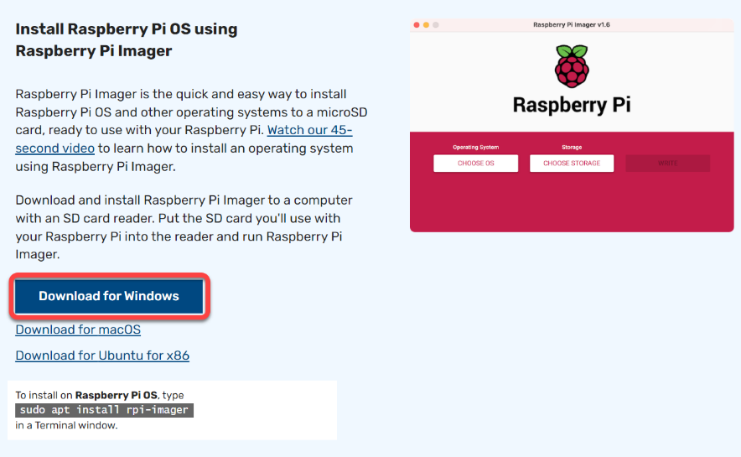

3. Now, click the **Install** button to install Raspberry Pi Imager on your computer.

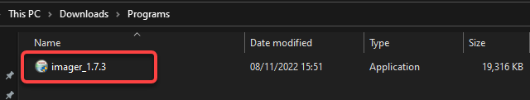

4 Lastly, tick the checkbox below, click **Finish** to close the wizard, and run Raspberry Pi Imager.

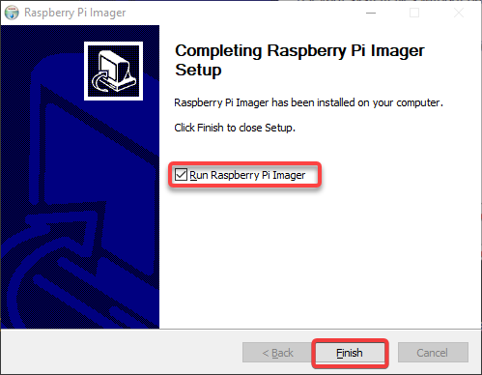

## Writing an Image to Your SD Card

Now that you have installed Raspberry Pi Imager for Windows, it is time to write an image to your SD card, also known as “imaging” or “flashing.”

1. On the main screen of the Raspberry Pi Imager, click the **CHOOSE OS** button to select the OS you want to install.

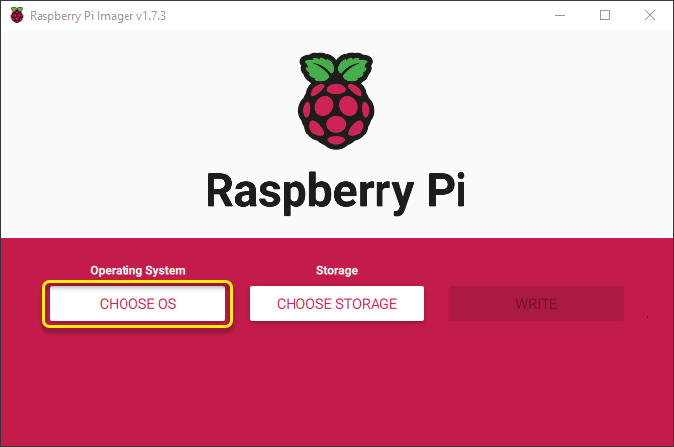

2.Click on Raspberry PI OS(other)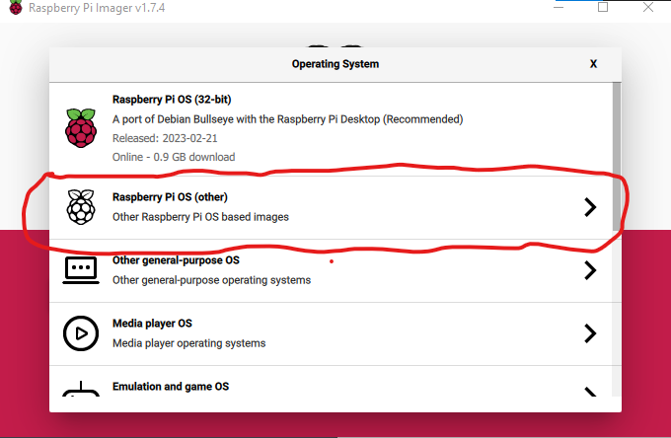

3)Choose Raspberry PI OS (64-bit) to install Raspbian 64 bit operating system on SD-Card.

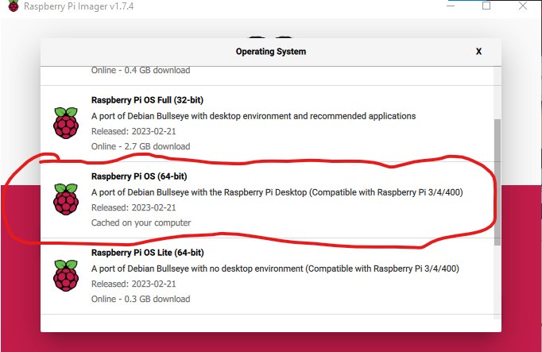

4)Configure the hostname and SSH settings on the **Advanced options** window with the following:

* Tick the **Set hostname** checkbox and provide a hostname for your Raspberry Pi to uniquely identify your computer on a network.Tick the **Enable SSH** checkbox to enable Secure Shell [(SSH](https://adamtheautomator.com/ssh-command-in-linux/)) access to your Raspberry Pi. SSH allows you to access your Raspberry Pi from another computer remotely.
* Select the **Use password authentication** option to require a password when you SSH to your Raspberry Pi.

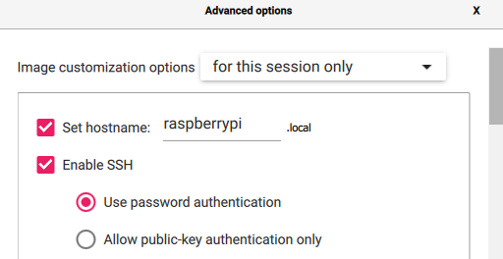

5)Then  **set username and password** checkbox and enter a username and a strong password for your Raspberry Pi. You will use these credentials to SSH into your Raspberry Pi once it has been imaged.



6).Then  **set locale settings** checkbox and select your preferred **Time zone** and **Keyboard layout** for your Raspberry Pi. Note that choosing your location from the list ensures the accurate time zone.

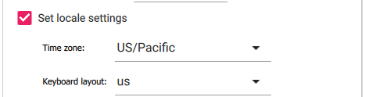

7) Under **Persistent settings**, enable the following:

* **Eject media when finished** – This setting helps to safely eject the SD card from your computer when the imaging process is complete.**Enable telemetry** – This setting helps the Raspberry Pi Foundation improve the Raspberry Pi Imager for Windows tool.

Keep other settings as is, and click **Save** to save your settings and close the window.

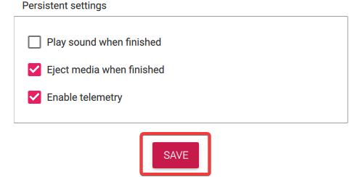

8. Once saved, click **WRITE** to begin writing the OS your selected settings to your SD card.

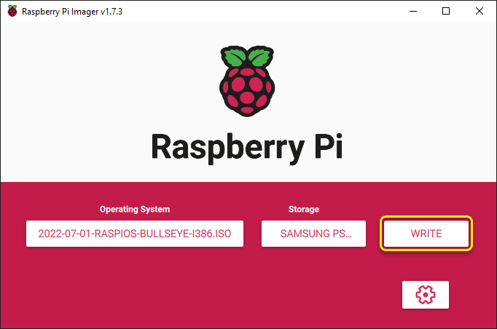

9) Then click **YES** when prompted to confirm writing the OS

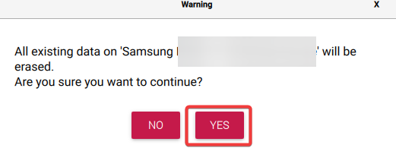

A new window opens, displaying the progress of the write operation, this process can take a while.



10. Finally, click **CONTINUE** to close the message box and return to the main screen once complete.

Finishing writing the image

**Booting Up Raspberry Pi via SD Card**

You have successfully managed to write an image to your SD card. But to verify the image works, you will have to boot your Raspberry Pi from the image.

1. Remove the SD card from your computer.
2. [Insert the SD card](https://projects.raspberrypi.org/en/projects/raspberry-pi-setting-up/3) into your Raspberry Pi and connect the power supply. The green LED on your Raspberry Pi should start flashing, which indicates the Raspberry Pi is booting up.
3. Wait a minute or so for your Raspberry Pi to boot up. Once up, Raspberry Pi will be displayed on your screen, as shown below. The output below verifies Raspberry Pi is working and the image was successfully written to your SD card. Congratulations! You have now imaged your first SD card with the Raspberry Pi Imager for Windows tool.

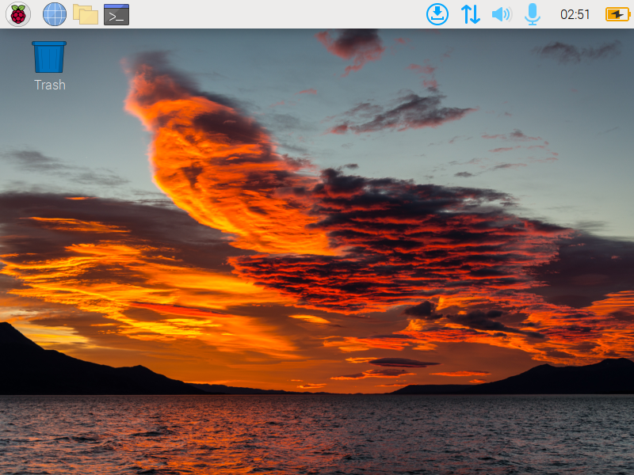Booting up Raspberry Pi

**Conclusion**

The Raspberry Pi Imager for Windows provides a quick way to write OS images on your SD card. And in this tutorial, you have learned how to install Raspberry Pi Imager, write an image, and boot to your Raspberry Pi via SD card.

Experimenting with the Raspberry Pi can be fun. And since Raspberry Pi is a [low-cost and low-power](https://raspberrypi.stackexchange.com/questions/5033/how-much-energy-does-the-raspberry-pi-consume-in-a-day) device, why not learn about building [LAMP web servers](https://projects.raspberrypi.org/en/projects/lamp-web-server-with-wordpress) and hosting your website? Keep Raspberry Pi running 24/7 without breaking the bank!

**Related:**[Using Terraform Provisioner to Deploy a Web Server](https://adamtheautomator.com/terraform-provisioner/)

Hate ads? Want to support the writer? Get many of our tutorials packaged as an ATA Guidebook.